EXPERIMENT 9
PROBLEM :
Implement a transport layer simulation to demonstrate process -to-process
Communication using UDP,TCP AND SCTP Protocols. Compare these protocols in terms of connection establishment ,data transmission , and congestion control using Cisco Packet Tracer.
AIM:
Transport Layer Simulation : UDP ,TCP AND SCTP Comparison
PROCEDURE:
Step 1: Setup the Network Environment
1. Open Cisco packet Tracer
2. Create a new project
3. Add the following devices:
. Two PCs (PC0 and PC1)
. One switch (2960)
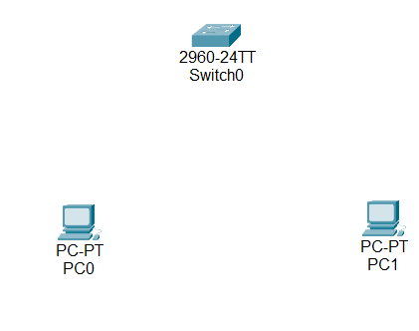

4. Connect:
. PC0 -Switch
. PC1 – Switch
Using copper straight through cables
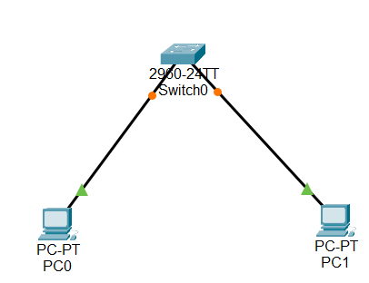
Step 2: Configure IP Addresses
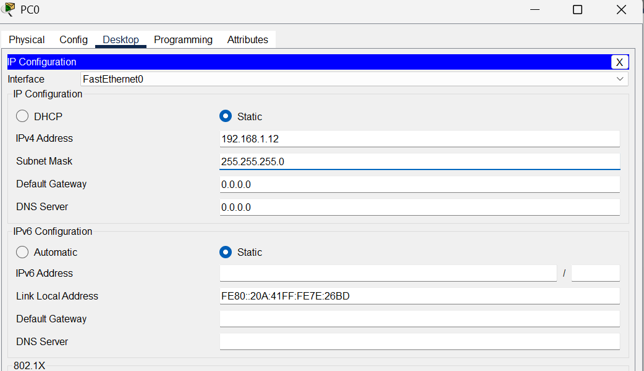

Step 3: Test Connectivity
1. Open command prompt on pc0 and ping
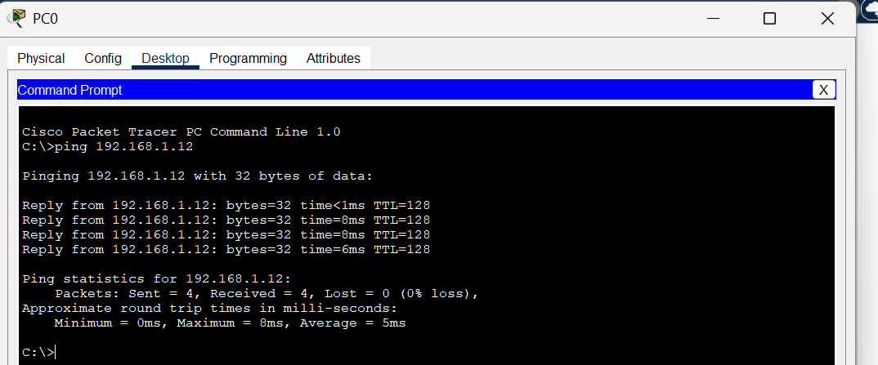
## UDP COMMUNICATION:
1. Switch to Simulation Mode
2. Select Add Simple PDU
3.Click on:
. PC0(Source)
. PC1(Destination)
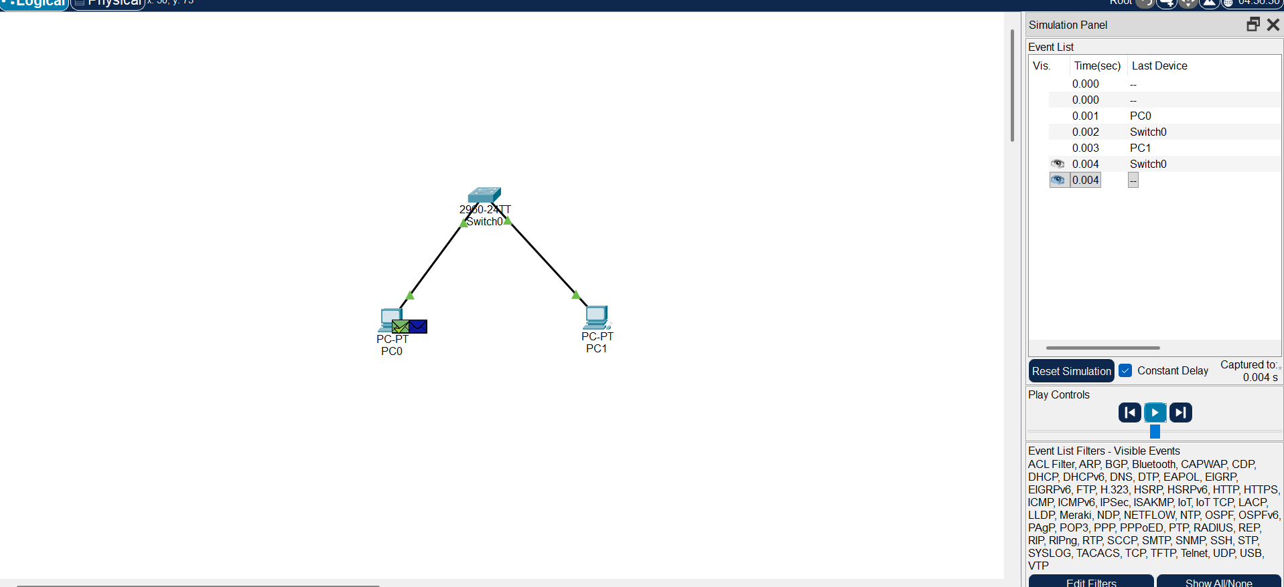

# SIMULATE TCP COMMUNICATION
1. Open Cisco Packet Tracer and create a new project
2.Add 2 PCs and 1 Switch , then connect them using copper straight through cable.
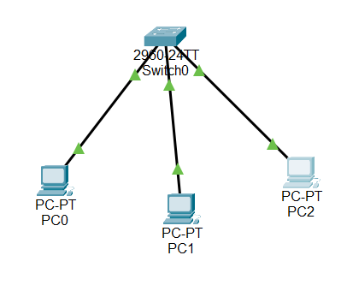
3. Assign IP addresses
. PC0 – 192.168.1.1
. PC1 – 192.168.1.2
. PC2 – 192.168.1.3
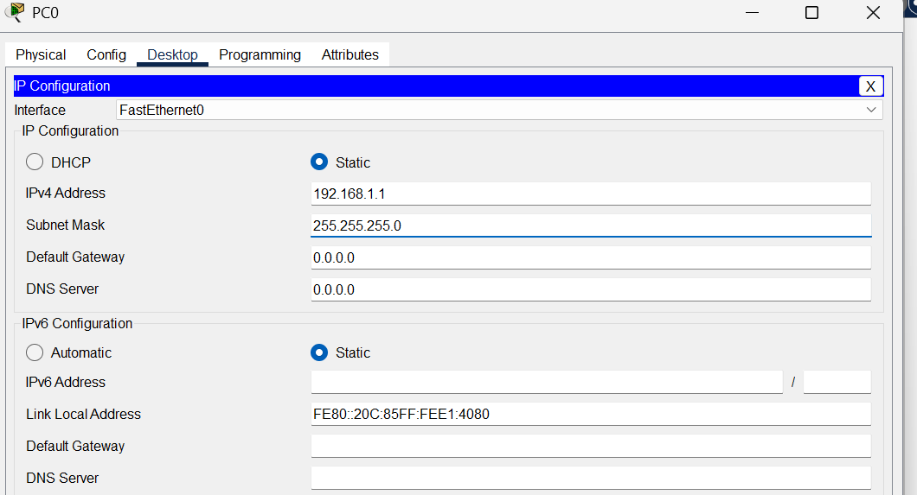

4. Observe Packets in simulation Mode and verify communication is successful
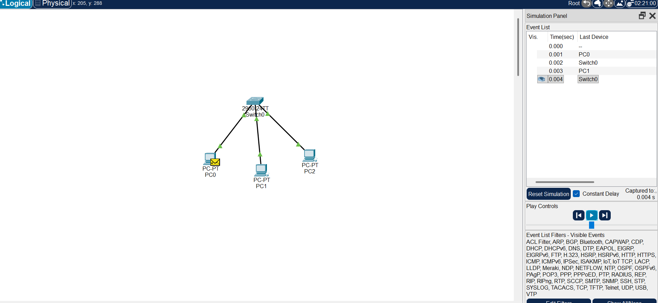
TCP(Transmission Control Protocol)
. Connection-oriented Protocol
. Reliable data transfer
. Maintains correct order of data
. Uses acknowledgments
. Retransmits lost packets
UDP(User Datagram Protocol)
. Connectionless protocol
. Unreliable data transfer
. Does not maintain order of data
. No acknowledgments
. No retransmission of lost packets
. No flow control
. No congestion control

